Bimonthly Summary Content:

Online Observer Catalog Submission Webpage.
A new observer catalog submission webpage is now online on the MMT website for observers to utilize. This tool will help observers submit their existing catalogs or generate new catalogs from scratch. The page allows for observers to type in a target name (such as ‘vega’ or ‘M45’) and that target’s RA, DEC and proper motion are all automatically generated and added to the catalog. This works by making a connection under-the-hood (using a combination of Ajax & SOAP) to the SIMBAD database. The catalog format is interchangeable with other Steward Observatory telescopes so even non-MMT observers can also utilize this tool to generate their own catalogs if desired.
http://hacksaw.mmto.arizona.edu/catalogs/
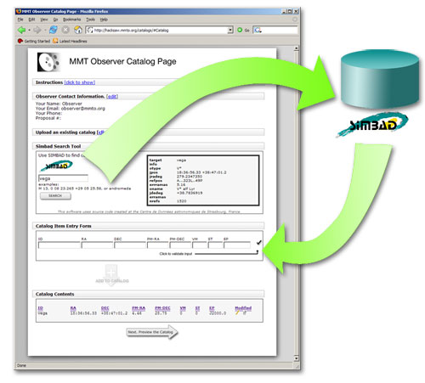

HORIZONS Ephemerides TCS Tool.
To help make tracking non-sidereal targets easier, a new tool has been developed for the MMT Telescope Control System. The MMT Horizons Ephemerides tool accepts a name of a non-sidereal object, it then establishes a connection behind the scenes (using PHP CURL & Ajax) to NASA JPL’s Solar System Dynamics database to generate a 1 minute interval ephemeris for any desired time span. Modifications have been made to the Mount crate to accept this new ephemeris table and to perform the interpolation of the ephemeris table.
